**Project Documentation**

**Online Restaurant-Table Booking**

**Web Application**

On fulfilment of Digital Internship in

**Exavalu**

BY - **Group G**

Team Members

**Nilkantha Paramanik**

**Apurba Bhattacharjee**

**Simol Gandhi**

**Paulomi Bandyopadhyay**

**Aman Kumar**

Introduction

Restaurants are the most marched for business category on the internet and many restaurants now have a website. A well designed website will attract new customers to your restaurant, online reservations are increasing rapidly with so many consumers seeking out restaurants via the web, and a well-designed website for a restaurant needs a few key elements that a customer looking to book would want to see. So we are going to develop this system where a web application for the users, admin and restaurant that completes the package of restaurant & bookings. The user can browse through number of restaurants on the basis of cuisines and check for all their details, can book a table by comparing the food menus as well and other functionalities. The user can cancel and check his booking history. While the admin is responsible to add a restaurant and check the booking history or user list. The restaurant user can check all the booking and enter check in and check out status.

**-:Objective:-**

The main objective of the Online Restaurant Table-Booking Web Application is to provide a one platform solution for online restaurant table booking. This app will save the precious time of the users and the user friendly UI and easy booking system will give a better experience to the user.

**-:Features:-**

Our Restaurant Table Booking Application has following key features:-

★ People can easily register on our website using his/her Email Id

★ Registered users can log in on website using his/her Email and Password

★ Allow your users to search for different restaurants, cafes, pubs, and bars by location and cuisines.

★ With an easy-to-order feature, the user can place an order of selected dishes and food with just a few simple taps on the screen.

**:-Benefits of Restaurant Table Booking Application:-**

1. Makes the online table booking and ordering process easier
2. Efficient customer and order management
3. Time saving and user friendly UI
4. Better customers data
5. Greater reach

**Key Features**

* Searching menu: Allow your users to search for different restaurants, cafes, pubs, and bars by location and cuisines. Users can go through the menus, and choose an item from using the search filter, users can easily find their favorite eating places.
* Order placement: With an easy-to-order feature, the user can place an order of selected dishes and food with just a few simple taps on the screen. They just need to cross-verify their preferred dish and proceed with check-out.
* Customer Relationship Management (CRM): This feature in the online food ordering system helps in organizing the comprehensive data regarding customers. Their current online order patterns, sales details, transaction details, likes-dislikes, canceled orders. It is a fusion of customer feedback and a loyal customer database.
* Payment gateway integration: Integrate your app like GrubHub and UberEats with Payment Gateways like Braintree or Stripe and allow users to pay by credit/debit card. Make sure that you provide the users with multiple payment options.

**-:Web Aplication:-**

**User**

* **Registration:** To access the system, user needs to register with his/her basic registration details.
* **Login:** After successful registration, user can login using their valid username and password.
* **Profile:** User profile details will be displayed& also can update their contact number.

**Restaurant Page:** Restaurant details will be displayed where user can select a date & time for booking.

* **View Tables:** User will book from the available tables at the selected restaurant. *
* **Bookings:** Here, user is shown current, previous and cancelled booking details.
* **Cancel Booking:** User can cancel their booked tables whenever necessary.
* **Notification:** The system will give a notification regarding the booking an hour prior to users booking. *
* **Reviews:** List of reviews that users have given will be displayed.

**Admin:**

* **Login:** Admin needs to login into their account to access the below given modules.
* **View Booking:** Admin can view all the booking details which is booked by the user.
* **Add Restaurant:** Add new restaurant details such as id, name, contact no., select a point on map, cost for 2 persons, cuisine, etc.
* **View Restaurant:** View all the added restaurants and even can delete them.
* **View Users:** View all registered users.

**Restaurant :**

* **Login:** Once the restaurant details are registered, a concern person of restaurant can login using their login credentials.
* **Add Menu:** Add any number of menu.
* **View Booking:** View booking of Restaurant can view its bookings.

**-:Working:-**

The website basically deals with booking of food from their favourite restaurant in a single platform. The user can access their respective restaurant and can book their favourite meals from the website very easily and in an efficient manner as the website has a user friendly User Interface (UI). The website has an updation as well as deletion feature of meals . It also has online table booking in their favourite restaurant for whichever duration he/she is comfortable. It also has the database which includes the history of their previous orders so that he/she can easily book the previously order meals within no tme.

It has a hassle-free and responsive UI which would help the user to include data in an efficient manner.

# **-:THEORETICAL BACKGROUND:-**

**The Project is comprised of the following :-**

1. **HTML**:-The **HyperText Markup Language**, or **HTML** is the standard markup language for documents designed to be displayed in a web browser. It can be assisted by technologies such as Cascading Style Sheets (CSS) and scripting languages such as JavaScript.
2. **CSS**:-**Cascading Style Sheets** (**CSS**) is a style sheet language used for describing the presentation of a document written in a markup language such as HTML.[[1]](https://en.wikipedia.org/wiki/CSS#cite_note-1) CSS is a cornerstone technology of the World Wide Web, alongside HTML and JavaScript.
3. **JSP:-**JSP technology is used to create web application just like Servlet technology. It can be

thought of as an extension to Servlet because it provides more functionality than servlet such as expression language, JSTL, etc.

1. **JS:-JavaScript** is a programming language that is one of the core technologies of the World Wide Web, alongside HTML and CSS. Over 97% of websites use JavaScript on the client side for web page behavior, often incorporating third-party libraries.All major web browsers have a dedicated JavaScript engine to execute the code on users' devices.
2. **jQUERY:-**jQuery is a fast, small, and feature-rich JavaScript library. It makes things like HTML document traversal and manipulation, event handling, animation, and Ajax much simpler with an easy-to-use API that works across a multitude of browsers. With a combination of versatility and extensibility, jQuery has changed the way that millions of people write JavaScript.
3. **AJAX:-**is a set of web development techniques that uses various web technologies on the client-side to create asynchronous web applications. With Ajax, web applications can send and retrieve data from a server asynchronously (in the background) without interfering with the display and behaviour of the existing page. By decoupling the data interchange layer from the presentation layer, Ajax allows web pages and, by extension, web applications, to change content dynamically without the need to reload the entire page.[[3]](https://en.wikipedia.org/wiki/Ajax_(programming)#cite_note-wrox-3) In practice, modern implementations commonly utilize [JSON](https://en.wikipedia.org/wiki/JSON) instead of XML.
4. **JAVA:-**Java is a programming language and a platform. Java is a high level, robust, object-oriented and secure programming language.

Java was developed by *Sun Microsystems* (which is now the subsidiary of Oracle) in the year 1995. *James Gosling* is known as the father of Java. Before Java, its name was *Oak*. Since Oak was already a registered company, so James Gosling and his team changed the name

from Oak to Java.

1. **MODULE USED :-**
   1. **STRUTS2**
   2. **BOOTSTRAP 9.DATABASE USED:-**

**a. MySql**

**System Flow Diagram**

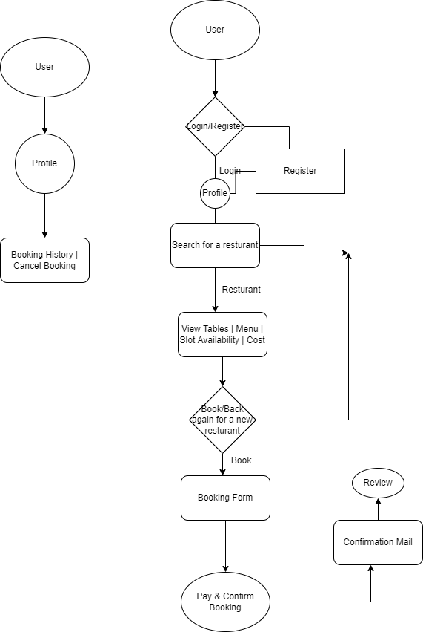

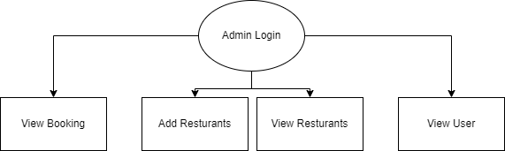

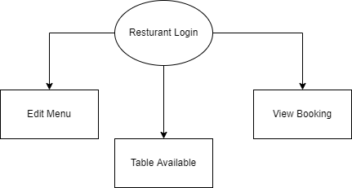

**Database Structure:**

|  |  |  |  |  |  |  |
| --- | --- | --- | --- | --- | --- | --- |
| **Restaurant** | **Table** | **Customers** | **Reservation** | **Menu** | **Admin** | Orders |
| **restaurant id** | **table id** | **customer id** | **reservation id** | food items | **id** | **order id** |
| name | Restaurant | name | Restaurant id | price | name | restaurant id |
| location | Capacity | ph no. | Customer id |  | email | customer id |
| time |  | mail id | date/time |  | ph no. | Items |
| menu id |  | password | orders id |  | password |  |

**Entity Relationship Diagram**

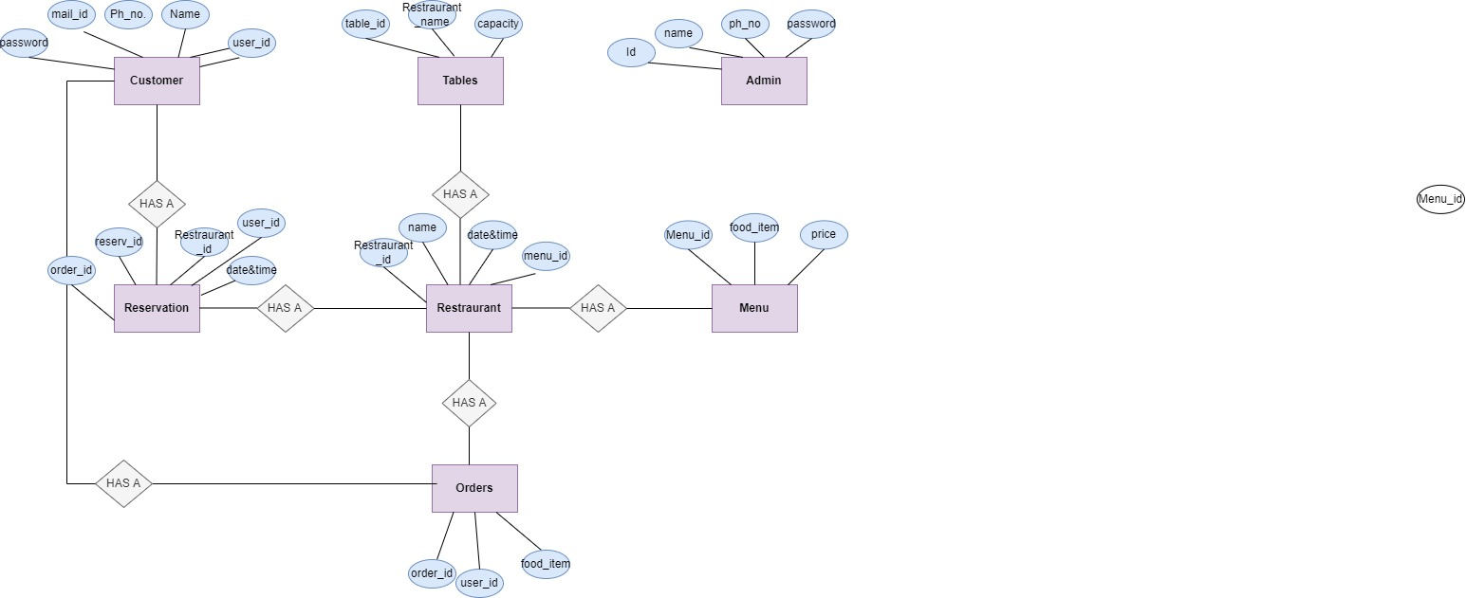

**Data Flow Diagram**

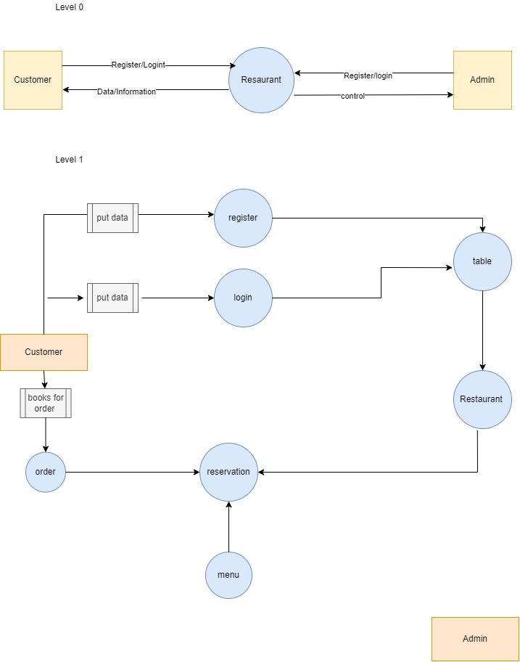

**-:Future Scope:-**

This order food online system project aimed at developing an online food ordering system that can be used in small places, and medium cities firstly and then on a large scale. It is developed to help restaurants to simplify their daily operational and managerial task as well as improve the dining experience of customers.

And also helps restaurants develop healthy customer relationships by providing good services. The system enables staff to let update and make changes to their food and beverage list information based on the orders placed and the orders completed.

This system is developed to **provide service facility to restaurant and also to the customer**. This restaurant management system can be used by employees in a restaurant to handle the clients, their orders and can help them easily find free tables or place orders.

**-:Conclusion:-**

With online ordering on board you will enrichen your customer experience by making the process of ‘placing orders’ a lot easier. It will show that you value your customer’s time. Online ordering will guarantee a ‘level up’ to your web presence. And a good web presence will make you stand out in the search engine rankings and bring more customers to you.

Online ordering will boost your productivity by eliminating the inefficient process of taking orders. It will help you to plan and implement an adaptive marketing campaign.

Utilising the latest online ordering technology for your restaurant will also help you to tap into a massive customer base which is tech-savvy and believes in ‘online way’.

.